SFD Lite Report

City Name
Country

This SFD Lite Report was prepared by organisation name

Date of production/ last update: dd/mm/yyyy

SFD Lite Report
An SFD Lite report allows you to prepare an SFD Graphic with a minimum amount of supporting data and referenced sources for that data. The data to be collected focuses on the management of excreta through the sanitation service chain to identify the service outcomes, without the supporting service delivery context information. Such a report may prove to be a valuable starting point from which to then develop a more detailed SFD Report at a later stage.
For a fuller and more systematic analysis, the SFD Promotion Initiative (SFD PI) has developed recommended methods and tools for preparing a full SFD Report consisting of the SFD Graphic, the analysis of the service delivery context and enabling environment for service provision in the city, and the complete record of data sources used.
More details are provided in the SFD Manual.

- The SFD Lite Report includes the SFD Graphic, brief contextual information and the record of data sources used, typically this is 8 to 10 pages long
- It documents the production process, the assumptions made and key outcomes of the SFD assessment.
- The SFD Graphic, the SFD selection grid and SFD matrix are produced with the SFD Graphic Generator (online and offline version available)
- More detailed information on How to make an SFD can be found here.

The SFD Graphic
Add your own SFD graphic. Replace the graphic by right clicking on the image below and selecting ‘change picture’ and insert the png version of your SFD graphic.
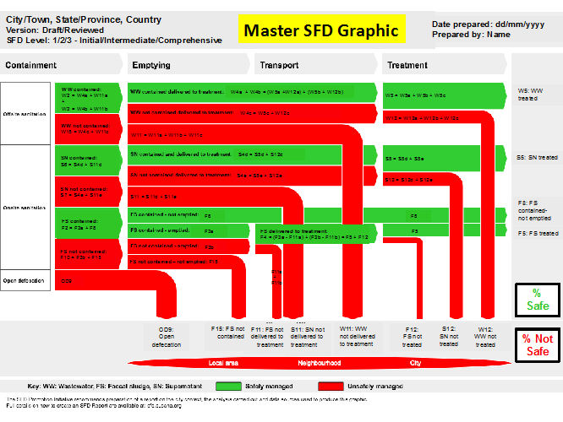
SFD Graphic for [city name]

SFD Lite information
Produced by:
Add here:
- Name(s) of the organisation that produced the SFD Lite.
- If applicable, acknowledge the support of people who contributed to the production of the SFD Lite but are not necessarily partners; e.g. produced by XXX, with support / close collaboration / inputs from XXX.
Collaborating partners:
If relevant:
- Names of all collaborating partners / organizations here.
Date of production: DD/MM/YYYY

General city information
Mention in brief general information on the city or town, such as:
- Population (including diurnal and seasonal variations of population)
- City boundaries (which boundary was chosen for the SFD and why). Particularly important if it differs from the political/administrative boundaries
- Important spatial and housing features (population density, informal housing arrangements etc.)
- Specific challenges for sanitation services e.g., high groundwater, flood plains, steep hillsides etc. (optional)

Service outcomes
Add here:
- Include a brief overview of the different sanitation systems through the sanitation service chain, based on the choices in the selection grid. If necessary, provide any locally used terms for specific technologies and how these were interpreted in the assessment.
- Describe the main issues (both positive and negative) that affect the sanitation service delivery and how these have been interpreted. Paste the SFD Matrix below this paragraph and provide explanatory text for each of the percentages included in the table.
Add here:
- The png of the SFD Matrix you created
Table 1: SFD Matrix for [city name]
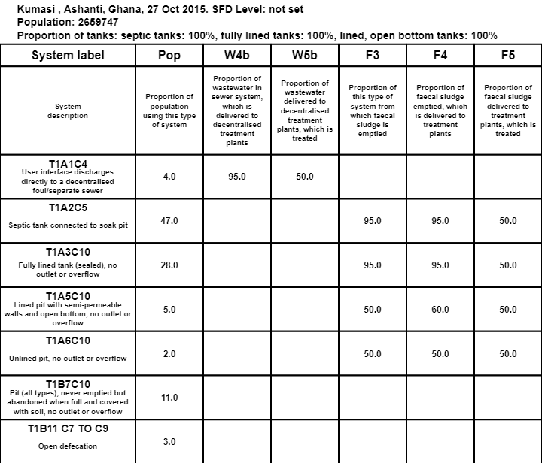

Describe the overall outcome as indicated by the SFD Graphic, i.e., the proportion of safely managed sanitation and the proportion of unsafely managed sanitation.
Add here:
- The png of the SFD Graphic you created (or, if report is short, refer to figure in Section 1).
Figure 1: SFD Graphic for [city name]

Add any further details:
- For example, explain whether the risk of groundwater pollution is estimated to be significant or low, and explain why. For guidance, please click this link.

Data and assumptions
Describe here:
- The availability and accessibility of data
- Quality of data available and used
- Identified data gaps
- Major assumptions that were made

Context adapted SFD Graphic (if applicable)
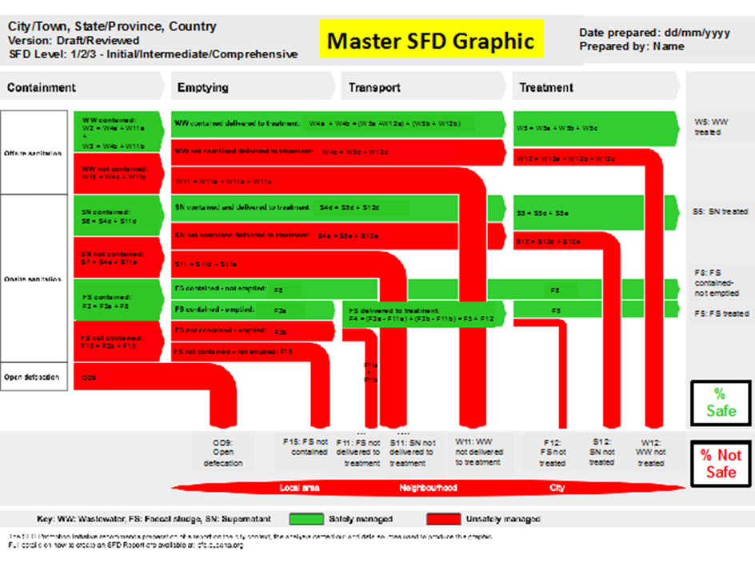
Figure 2: Context adapted SFD Graphic for [city name]
Describe here:
- The variation in the adapted SFD graphic from the SFD developed using the Graphic Generator.
- Briefly explain the assumptions for the proposed context-adapted SFD graphic and its implications to local conditions.

List of data sources
Include a list of all data sources used for the production of the SFD Lite. For example, from:
- Reports and literature
- Key informant interviews
- Focus group discussions

SFD City Name, Country, Year

Produced by:
Institution, Name of Author (if applicable)
Institution, Name of Author (if applicable)

Editing:
Institution, Name of Author (if applicable)
Institution, Name of Author (if applicable)

© Copyright
All SFD Promotion Initiative materials are freely available following the open-source concept for capacity development and non-profit use, so long as proper acknowledgement of the source is made when used. Users should always give credit in citations to the original author, source and copyright holder.

This SFD Lite Report is available from:
www.sfd.susana.org

