SFD Report

City Name
Country

Status (Final / Draft) Report

This SFD Report - SFD level - was prepared by organisation name.

Date of production:
Last update:

SFD Report City, Country, year
Produced by:
Authors’ names
©Copyright
All SFD Promotion Initiative materials are freely available following the open-source concept for capacity development and non-profit use, so long as proper acknowledgement of the source is made when used. Users should always give credit in citations to the original author, source and copyright holder.

This Executive Summary and SFD Report are available from:
www.sfd.susana.org
SFD Reporting Template
Comment: This reporting template provides an outline to be followed when producing the final SFD report. Guidance is provided on which data to report and to what level in the SFD Manual. This template includes:
- Executive summary
  - The Executive summary is a 4-page document. The purpose of the Executive summary is to present the key outcomes of the assessment. It is not a summary of the detailed report (see below), but rather presents key conclusions from the assessment.
  - The Executive summary supports the SFD graphic, so that the graphic is not a stand-alone component.
  - The SFD graphic on page 1 is produced with the SFD Graphic Generator. This Executive summary, together with the detailed report (see below) can be uploaded to the SFD website portal after being reviewed by the SFD PI.
- Detailed report
  - There are three levels of SFD Report that can be produced (Initial, Intermediate and Comprehensive) and they differ on the basis of five main criteria: the purpose of the SFD, the resources required, the extent of data collected, the extent of stakeholder engagement and the depth of data analysis. The table below provides you with an overview of the information required, according to the different level of SFD.
  - This is a report including all information collected as part of the implementation of the SFD production process. The report should be concise but cover all relevant and credible information collected, according to the level of the SFD as indicated in the table below. The report can be provided on request as a supplement to the Executive summary. It should not be longer than 20 pages, with additional details provided in the Appendix.
Enabling environment to service delivery | Data collected at all stages of the service chain | Reporting  = required = not required If collected = recommended
 |  | Level of SFD
 |  | Initial (1) | Intermediate (2) | Comprehensive (3)
 | Policy
 | Institutional roles
Policy, legislation and regulation | Service provision
 | Standards
 | Targets |  | Include if data is collected
Planning | Investment |  | Include if data is collected
Equity | Choice |  | Include if data is collected
 | Reducing inequity |  | Include if data is collected
Output | Quantity / capacity |  | Include if data is collected
 | Quality
Expansion | Demand |  | Include if data is collected
 | Sector development |  | Include if data is collected
Service Outcomes | Quantity
On the following pages, text starting with “#” requires the author to insert information. Text starting with “##” is a comment and is to be deleted before the final version of the report is shared.

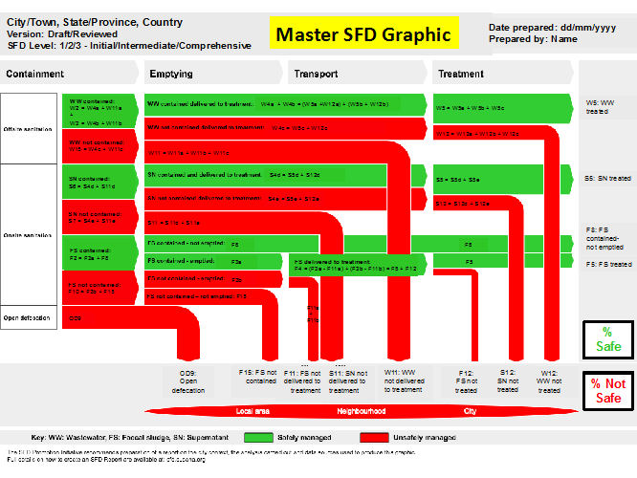
Replace the diagram by right clicking on the image and selecting ‘change picture’

SFD Level:
Inform the level of this SFD report: Initial / Intermediate / Comprehensive
Produced by:
Put the name(s) of the organization that produced the SFD. If applicable, you can acknowledge support of people who contributed to the production of the report but are not necessarily partners; e.g. produced by XXX, with support / close collaboration / inputs from XXX.
Collaborating partners:
Put the names of all collaborating partners/ organizations here. In the instance that there are no collaborating partners, delete this section.
Status:
The current status of the SFD should go here: draft or reviewed
Date of production: DD/MM/YYYY

Mention in brief general information on the geographical context, focusing on:
City boundaries (which boundary was chosen for the SFD and why). Particularly important if it differs from the political/administrative boundaries)
Population (focus particularly on variances of population through diurnal population and seasonality)
Important spatial features (population density, informal housing arrangements etc.)

The section on the service outcomes context should always start at the top of page 2.
Provide a brief overview on technologies and methods used for different sanitation systems through the sanitation service chain; this should be focused on positive/negative highlights, which mainly contribute to the percentages on the SFD graphic (details will be given in detailed report). For example: A high percentage of onsite sanitation technologies that don’t contain faecal sludge.
The risk of groundwater contamination could be discussed. For example, the use of groundwater for drinking purposes above a certain percentage results in a high percentage of red arrows if systems do not contain faecal sludge.
When using bullet points they should look as follows:
- Bullet point one
- Bullet point two
- Bullet point three

A brief analysis of the city’s service delivery context should go here, including:
An overview of each step in the sanitation service chain with a particular focus on positive characteristics and on gaps hindering effective service delivery.
Highlight key aspects, according to the level of SFD report:
For Level 1 (Initial SFD), this would be; Policy, legislation and regulation (with reference to the stakeholder overview);
For Level 2 (Intermediate SFD) and Level 3 (Comprehensive SFD), this would be; Policy, legislation and regulation, Planning, Equity, Outputs and Expansion (again, with reference to the stakeholder overview); Conclusions that are being drawn from the service delivery context description/analysis

A description of the stakeholders and the enabling environment for sanitation service delivery should go here focusing on the regulatory framework and who is responsible to implement and control service delivery.
You may want to include a table with the key stakeholders for service delivery (example given below); however, the detailed stakeholder analysis should be included in the detailed report
Table 1: Title (Source/institution and year)
Key Stakeholders | Institutions / Organizations /
Public Institutions | E.g. City Council, Ministry of Health, Ministry of Local Government etc.  Utility
Non-governmental Organizations | e.g. NGO, CBO, Faith-based Organizations,
Private Sector | e.g. private emptiers
Development Partners, Donors | Xxx, yyy, zzz
Others | Academia
If using bullet points they should look as follows:
- Bullet point one
- Bullet point two
- Bullet point three
If you are going to be inserting images at any point in this document they should be placed in alignment with the correct column. The width should not exceed that of the column itself. An example follows:
Figure 1:Title (Source: Person/institution and year)
Make sure texts and pictures do not overlap.

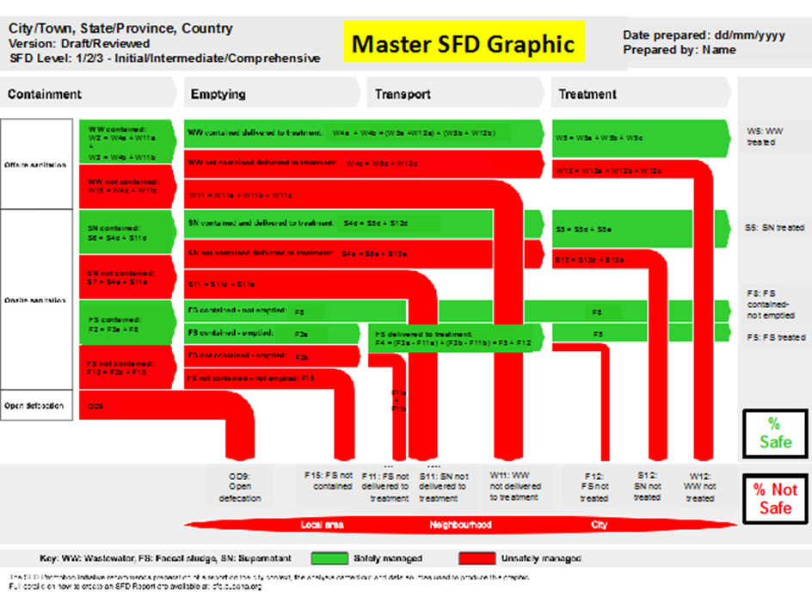 Replace the graphic by right clicking on the image and selecting ‘change picture’
Figure 2: Title (Source: Person/institution and year)

Describe the variation in the adapted SFD graphic from the SFD developed using the Graphic Generator.
Briefly explain the assumptions for the proposed context-adapted SFD graphic and its implications to local conditions.
Describe the process of the SFD development, including
Limitations e.g. if any deviations to the standard methodology had to be made
This can include comments on the SFD and whether or not it reflects the reality of the city.
If the SFD graphic prepared using the Graphic Generator does not visualize the city’s situation sufficiently – from the author’s or government’s
point of view – please describe here briefly the reasons for the same.

Provide an overview of the type of data sources used to produce the report, including the number of key informant interviews and focus group discussions conducted.
Comment on the availability of data, identified data gaps and major assumptions that had to be made.
Include an abbreviated list of all data sources used for the production of the SFD report.
- Data source one
- Data source two
- Data source three

General document guideline:
SFD City Name, Country, Year

Produced by:
Institution, Name of Author (if applicable)
Institution, Name of Author (if applicable)

Editing:
Institution, Name of Author (if applicable)
Institution, Name of Author (if applicable)

© Copyright
All SFD Promotion Initiative materials are freely available following the open-source concept for capacity development and non-profit use, so long as proper acknowledgement of the source is made when used. Users should always give credit in citations to the original author, source and copyright holder.

This Executive Summary and the SFD Report are available from: www.sfd.susana.org
- Font style is Arial
- Heading font is bold
- Heading font size is 11
- Body font size is 10
- Font colour is black, text 1, lighter 35% (as you see it in the whole document)
- All text has 1.0 line spacing
- There should be a 1.0 line space after each body of text, before the new heading.
- The document should always be divided into two columns
- You should insert the current date in the footer by double clicking on it and editing the text
- You should edit the document heading by double clicking on the header.
- All images should be captioned: Figure 1: Image title (source: Person or institution and year) or Table 1: This is done by right clicking on the image and selecting ‘insert caption’
- All images should be the same width as a column except for the diagram on page one which should be the width of two columns
- The last page of the document always ends with the SFD Promotion Initiative Logo set (bottom left column) and the Imprint (bottom right column)
- Adding the information of context-adapted SFD graphic into the current format would mean that the executive summary will be 5 pages long.

Table of Content
1 City context IX
2 Service Outcomes 1
2.1 Overview 1
2.2 SFD Matrix 1
2.3 SFD Graphic 2
2.4 Context-adapted SFD Graphic (Optional) 2
3 Service delivery context 2
3.1 Policy, legislation and regulation ## applies for all levels 2
3.1.1 Policy 2
3.1.2 Institutional roles 2
3.1.3 Service provision 2
3.1.4 Service standards 2
3.2 Planning ## applies always for level 3 and only for level 2 where data have been collected 2
3.2.1 Service targets 3
3.2.2 Investments 3
3.3 Equity ## applies always for level 3 and only for level 2 where data have been collected 3
3.3.1 Current choice of services for the urban poor 3
3.3.2 Plans and measures to reduce inequity 3
3.4 Outputs 3
3.4.1 Capacity to meet service needs, demands and targets ## applies always for level 3 and only for level 2 where data have been collected 3
3.4.2 Monitoring and reporting access to services ## applies for all levels 3
3.5 Expansion ## applies always for level 3 and only for level 2 where data have been collected 3
3.5.1 Stimulating demand for services 3
3.5.2 Strengthening service provider roles 3
4 Stakeholder Engagement 3
5 Acknowledgements (Optional) 3
6 References 3
7 Appendix 4
7.1 Appendix 1: Stakeholder identification (Table 2: Stakeholder Tracking Tool) 4
7.2 Appendix 2: Tracking of Engagement (Table 3: Stakeholder Tracking Tool) 4
7.3 Appendix 3: Context-adapted SFD Graphic (Optional) 4
7.4 Appendix 4, etc.: … 4

List of tables
Table 1: Title IX

List of figures
Figure 1: Title 1

Abbreviations
ABC | Academia Brasileira de Ciencias

City context
## This section should be a maximum of one page
## Insert basic information (summary) about the city context here
# Country/City/Region
# Population
# Population growth rate
# Significant variations in population (e.g. diurnal, seasonal)
# Topography
# Climate
# Key physical and geographic features, including those affecting sanitation services (e.g. rivers, road infrastructure, industrial areas)
# Urban boundaries (incl. map highlighting significant areas)
General document guidelines:
- Font style is Arial
- Heading font size is 14 (Heading 1) and 12 (Heading 2 and 3)
- Body font size is 11
- Font colour is black
- All text has 1.15 line spacing
- You should insert the current date in the footer by double clicking on it and editing the text
- You should edit the document heading by double clicking on the header.
- All images should be captioned: Figure 1: Image title (source: Person or institution and year) or Table 1:. This is done by right clicking on the image and selecting ‘insert caption’
Table 1: Title
(Source/institution and year)
Key Stakeholders | Institutions / Organizations /
Public Institutions | e.g. City Council, Ministry of Health, Ministry of Local Government etc.  Utility
Non-governmental Organizations | e.g. NGO, CBO, Faith-based Organizations,
Private Sector | e.g. private emptiers
Development Partners, Donors | Xxx, yyy, zzz
Others | Academia

Figure 1: Title
(Source: Person/institution and year)

Service Outcomes
## This section, together with the following section “Service Delivery Context”, should have a maximum of 16 pages and applies for all SFD levels.
## This section describes and presents an analysis of data collected for the production of the SFD graphic. The level of detail depends on the level of assessment (Initial, Intermediate and Comprehensive assessment). The format of this section is up to the author.
## Chapter 5.4 SFD Graphic Generator, in the SFD Manual – Volume 1 provides guidance on how to use the SFD Graphic Generator to draw an SFD Graphic for any city. In addition, SFD Manual – Volume 2 presents in detail which data contributes to the different stages of the SFD itself. All data has to be reported here in detail.

Overview
## Provide the SFD Selection Grid (png) generated from the SFD Graphic Generator. Include any assumptions required at this stage. Describe:
# Range of offsite and onsite sanitation technologies and systems in use.
# Percentage contribution of excreta from different origin categories: households, shared or communal toilets, public toilets, institutions, commercial and industrial areas, restaurants and hotels
# Services: Information relating to the range of service providers and service provision, through the sanitation service chain

SFD Matrix
## Provide the SFD Matrix (png) generated from the SFD Graphic Generator and refer to each section of the matrix in the narrative. Include any assumptions required at this stage.
## As this section may result in a variety of structures, due to high variability in city contexts, it is up to the author how to best structure the narrative within this section. The following is a proposed structure with sections arranged around:
- Technologies and methods used for different sanitation systems through the sanitation service chain
- Percentages of the population using those systems and services along the sanitation service chain
- Risk of groundwater contamination, based on Groundwater pollution risk estimation (further guidance provided in section 5.4.3 Estimating risk of groundwater pollution, in the SFD Manual – Volume 1); covering the following information:
      - Vulnerability of the aquifer (e.g. geology, soil type, depth of groundwater table)
      - Expansion ## include only for field-based assessment
  - Lateral separation (e.g. distance between sanitation facilities and groundwater sources)
  - Groundwater supply (e.g. groundwater supply technology)
- Discussion of certainty/uncertainty levels of associated data used for the SFD Matrix

SFD Graphic
## Provide the SFD Graphic (png) generated from the SFD Graphic Generator and refer to overall proportions safely managed and unsafely managed. Add details on the main issues (both positive and negative) that affect the sanitation service delivery and result in the percentages on the SFD Graphic.

Context-adapted SFD Graphic (Optional)
## No need for this section if the SFD Graphic developed by GG is acceptable.
## Provide the adapted SFD Graphic in the Appendix.
## Explain the reasons for deviation from the master diagram and explain the adapted diagram by directly referring to modified section of the graphic in the narrative.
## Clearly state all the assumptions and limitations of the adapted SFD
## This section should not exceed description of one page (max)

Service delivery context
## This section, together with the previous section “Service Outcomes”, should have a maximum of 16 pages. The length and depth of this session will vary according to the level of SFD.
## Insert information that was collected, following the guiding questions from ‘Table 4: Questions and data collection methods to analyse the range of sanitation service chain’; “SFD Manual – Volume 1”, chapter 5 Producing the SFD: sanitation service chain analysis
## All inserted information has to be referenced according to the source and additionally entered into the Reference section of this report.

Policy, legislation and regulation ## applies for all levels

Policy

Institutional roles

Service provision

Service standards

Planning ## applies always for level 3 and only for level 2 where data have been collected

Service targets

Investments

Equity ## applies always for level 3 and only for level 2 where data have been collected

Current choice of services for the urban poor

Plans and measures to reduce inequity

Outputs

Capacity to meet service needs, demands and targets ## applies always for level 3 and only for level 2 where data have been collected

Monitoring and reporting access to services ## applies for all levels

Expansion ## applies always for level 3 and only for level 2 where data have been collected

Stimulating demand for services

Strengthening service provider roles

Stakeholder Engagement
## This section should be a maximum of three pages
## Describe the process of engagement throughout the implementation of the project (i.e. Key Informant Interviews and Focus Group Discussions, if applicable). If observations of service providers have been carried out, describe which data was collected, challenged or cross-checked through direct observations.

Acknowledgements (Optional)
Acknowledgements enable you to thank all those who have been involved and helped you in carrying out the research.

References
## All sources used in the document must be listed here. The following referencing style should be applied:
Harvard Reference Format
Example citation:
(Peal et al. 2014)
and accompanying full reference:
Peal, A., Evans, B., Blackett, I., Hawkins, P., and Heymans, C. 2014. “Faecal Sludge Management (FSM): Analytical Tools for Assessing FSM in Cities.” Journal of Water Sanitation and Hygiene for Development 4 (3): 371–83.
For more information on Harvard Reference Format visit: https://library.leeds.ac.uk/skills-citations-harvard

Appendix

Appendix 1: Stakeholder identification (Table 2: Stakeholder Identification)

Appendix 2: Tracking of Engagement (Table 3: Stakeholder Tracking Tool)

Appendix 3: Context-adapted SFD Graphic (Optional)

Appendix 4: etc.: …

SFD City Name, Country, Year

Produced by:
Institution, Name of Author (if applicable)

Editing:
Institution, Name of Author (if applicable)

© Copyright
All SFD Promotion Initiative materials are freely available following the open-source concept for capacity development and non-profit use, so long as proper acknowledgement of the source is made when used. Users should always give credit in citations to the original author, source and copyright holder.

This Executive Summary and the SFD Report are available from:
www.sfd.susana.org

